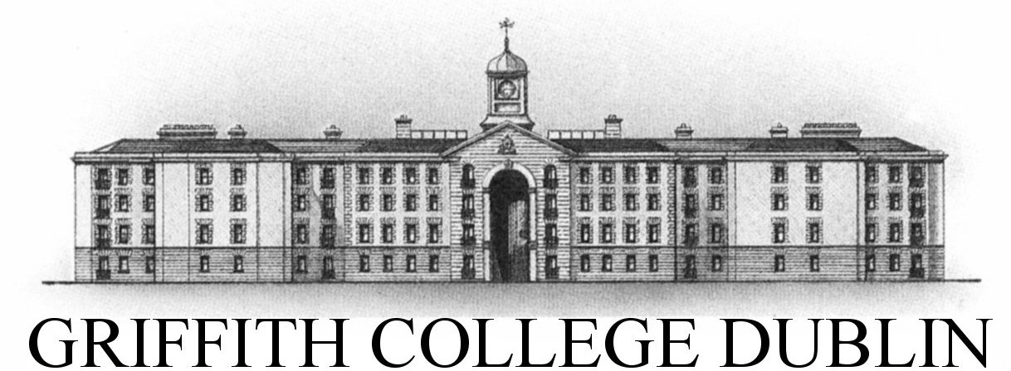

Course and Stage: | GBS MSCIB Strategic Human Resources
Lecturer | Suzanne Maher
Subject: | Strategic Human Resource Management
Study Mode: | Full time | X |  |  |  | Part-time
Assignment Title: Human Resource Management issues in
Assignment type: Individual
Word count: | 2,000- 2,500 |  |  |  | Weighting |  | 50%
Due date: | Week 10. See Moodle for actual date
Submit assignment | Turnitin via Moodle

Human Resource Management issues in Burke’s Fine Foods
Burke’s Fine foods is a cafe & fine food shop based in Galway city centre with 18 female full time staff.
Before Kay’s retirement, Jane visited the business to meet with Kay and the staff. During the meeting, Personnel Manager Kay Ryan currently manages Burke’s; she also looks after payroll, procurement and deals with the increasing number of issues presented to her by staff. Kay had worked in the business for over 35 years and has a reputation as a tough woman, with set ideas about staff, and how they are managed. A number of younger staff asked to work part time to manage childcare and Kay refused citing company policies and saying ‘I’ve managed the business successfully with full time staff; you can leave if you don’t like it here’. Despite the fact that the hourly rate was above average, staff turnover was high and new staff were recruited informally through current staff members. Training was on the job, with no external training provided. Kay felt she could train the new girls. Some of the staff members had contracts and others were unaware that they were entitled to one. Kay said she meant to get around to organising the contracts but had been too busy of late.
Aware that Kay was planning to retire, the owners of the business, who had no management skills, decided to sell the business and were delighted when an American entrepreneur, Jane Wynne, expressed an interest in purchasing the business.
Jane Wynne was home in Galway for a holiday. She was thinking of relocating when she saw the business for sale. She was thrilled with her purchase. She knew it would be hard work, combined with the fact that the business definitely needed a makeover.
With extensive experience in senior management and HR - Janes’ most recent position was as HR manager with a busy deli/restaurant in Chicago, she was keen to keep up to date with new food trends. Staff turnover was almost non-existent during her 15 years with her previous company and she knew that she had been a fair HR manager.
Jane sensed a hostility between staff members and Kay. Dressed mostly in dark uniforms, which looked decidedly worn, the staff were unsmiling and unengaging. In fact, Jane thought, they looked discontented. She also observed two of the staff eating in a food preparation area near the counter in full view of customers. She wondered if the negative culture that she was feeling, could be changed and if so how? Additionally she was keen to get to know the staff and thought team building exercises could work.
Janes plan was to take over the HRM function and recruit internally for a manager. She asked Kay if there was a staff member with management potential, but Kay did not believe that any staff member had any management potential, and in her opinion, most of them were lazy and had a bad attitude to work. She was happy to be leaving, she confided in Jane.
Jane left the cafe in deep thought wondering where and how she should start tackling the numerous issues she observed. She decided to list the issues as she observed and was confident she could find solutions and make positive changes in the business.

Read the case study above and using relevant research and examples, please answer the following three questions.
- Considering the case study above, what are the obvious issues that require immediate attention and why? Having identified a minimum of three obvious issues, what recommendations could you suggest that to amend these issues? (use research and examples to support your answer)

- Given what we know of Jane’s background, discuss the difference in her approach to HRM and the current HRM approach to date in the business. (use research and examples to support your answer)

- Examine the importance of Employee Engagement for management and staff. Explore and discuss in detail Employee Engagement strategies, which you would recommend for Jane for her staff? (use research and examples to support your answer)

SHRM Assignment 1 - Marking scheme
Marking Scheme:
Marking criteria  (out of 25) | Pass | 2.2 | 2.1 | 1st
Relevance  (3) | Material in answer must be directed at topic. Limited identification of implications of evident and relevance not always clear. | Material presented relevant to broad theme but not necessarily focused on questions asked . | A well-argued answer that addresses the topic. | Focused completely and concisely on question. All descriptive material used is deployed relevantly.
Knowledge  (8) | Partial grasp of main concepts. Displays limited understanding of topic/question. Significant errors and omissions. | Content restricted to basic principles. Generally accurate, some significant errors or omissions. Level of understanding of topic is sound. | Evidence of ability to integrate across information and shows and understanding of topic, an appreciation of some of its wider implications. Generally accurate and well informed, misses out some issues, some minor errors. | ALL elements of the work are exceptional and provide clear evidence of complete grasp of knowledge and understanding required by question. Shows ability to integrate across information and relate learning to broader context.
Analysis  (12) | Descriptive answer without analysis. | Slight analytical engagement with question but generally descriptive. Some evidence of ability to demonstrate integration across theories/sources but not evidence of ability to show an appreciation of some of its wider implications in terms of context. | Descriptive material is included but deployed relevantly and critically, though may be excess description in places. | Demonstrates exceptional (higher first) or strong (lower first) analytical ability.
Argument and Structure  (2) | Writes around topic but in disorganised fashion. Answer unfolds in haphazard manner. | Well organised structure evident, has some little opportunities for improvement. | Competently structured, logically presented. | Excellent organisation of topic, and logically structured answer.

